Project Name: Clone of Udemy

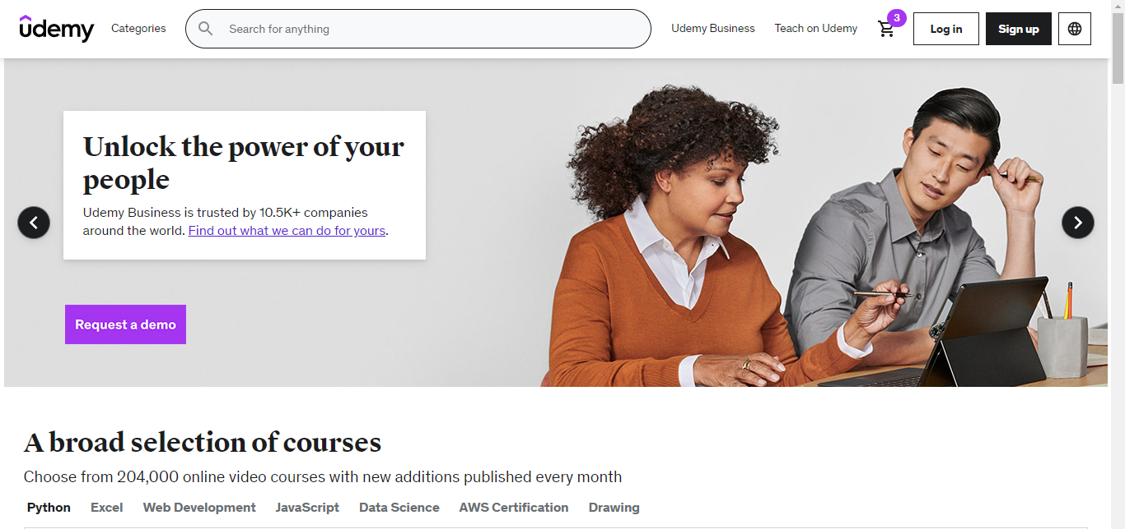

Vikash Kumar

Edureka presents

**Overview:**

Udemy is a massive open online course provider, and its learning experience arranges coursework into a series of modules and lessons that can include videos, text notes and assessment tests. Udemy’s video player has functional features like closed captioning and note-taking functions.

**Goals**

1. SignUp/Login page

2. Search Bar

3. Cart page

4. Payment page

**History**

In 2007, Udemy founders [Eren Bali](https://en.wikipedia.org/wiki/Eren_Bali) and [Caglar](https://www.linkedin.com/in/caglaroktay/?originalSubdomain=tr%7COktay) built a software for a live virtual classroom while living in Turkey. They saw potential in making the product free for everyone, and moved to [Silicon Valley](https://en.wikipedia.org/wiki/Silicon_Valley) to found a company two years later. The site was launched by Bali, Oktay Caglar and [Gagan Biyani](https://en.wikipedia.org/wiki/Gagan_Biyani) in early 2010.

Technologies used in Udemy

Front-End:

1. Html

2. Css

3. Bootstrap

4. React

Dynamic:

1. Javascript

2. Login and Logout

Database:

1. Mongodb

Code compilers:

1. Visual studio code

2. Git bash

3. Git hub